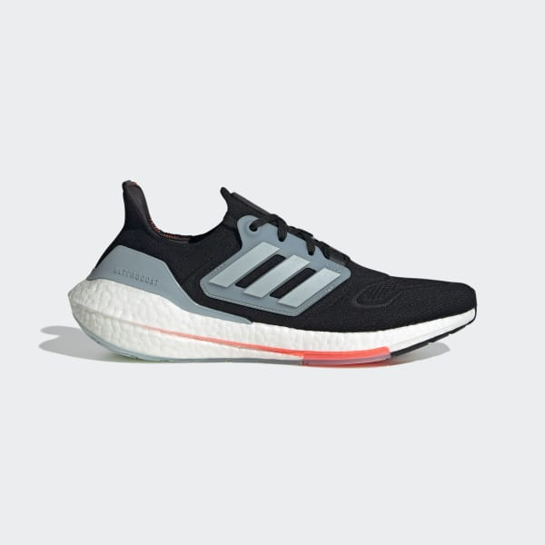Adidas Ultraboost 22 – Core Black/Magic Grey/Turbo

MYR799.00

Size – UK3.5 / UK4 / UK4.5 / UK5 / UK5.5 / UK6 / UK6.5 / UK7 / UK7.5 / UK8 / UK8.5 / UK9 / UK9.5 / UK10 / UK10.5 / UK11 / UK11.5 / UK12 / UK12.5 / UK13.5

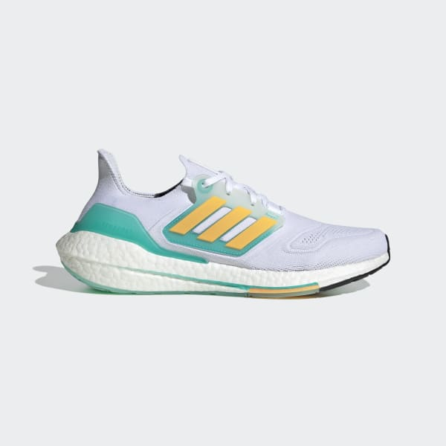

Adidas Ultraboost 22 – Crystal White/Legacy Indigo/Turbo

MYR799.00

Size – UK3.5 / UK4 / UK4.5 / UK5 / UK5.5 / UK6 / UK6.5 / UK7 / UK7.5 / UK8 / UK8.5 / UK9 / UK9.5 / UK10 / UK10.5 / UK11 / UK11.5 / UK12 / UK12.5

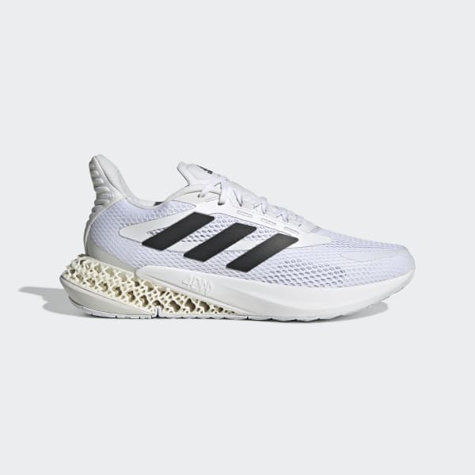

Adidas 4DFWD Pulse – Cloud White/Core Black/Crystal White

MYR749.00

Size – UK3.5 / UK4 / UK4.5 / UK5 / UK5.5 / UK6 / UK6.5 / UK7 / UK7.5 / UK8 / UK8.5 / UK9 / UK9.5 / UK10 / UK10.5 / UK11 / UK11.5 / UK12 / UK12.5 / UK13.5

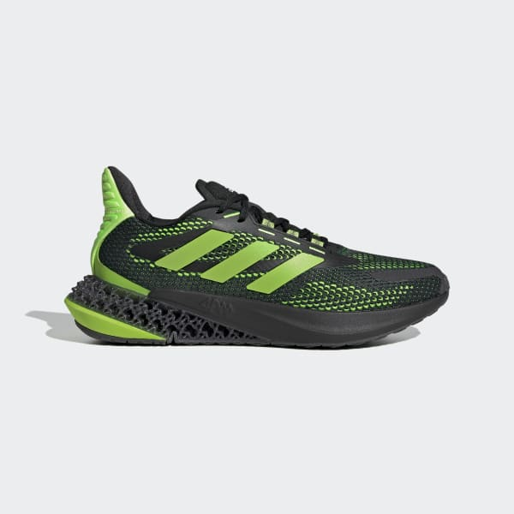Adidas 4DFWD Pulse – Core Black/Signal Green/Carbon

MYR749.00

Size – UK4 / UK4.5 / UK5 / UK5.5 / UK6 / UK6.5 / UK7 / UK7.5 / UK8 / UK8.5 / UK9 / UK9.5 / UK10 / UK10.5 / UK11 / UK11.5

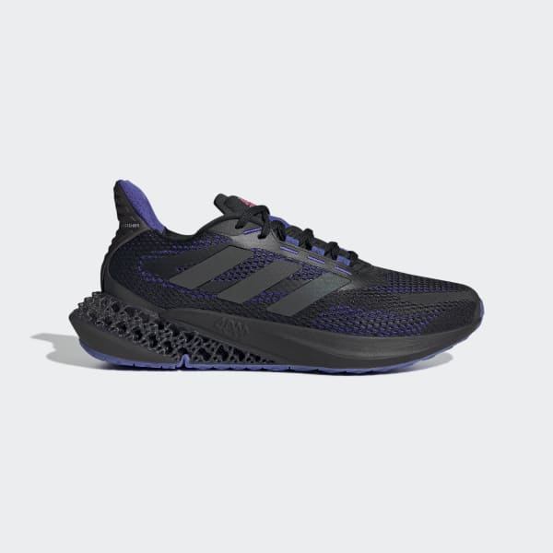Adidas 4DFWD Pulse – Core Black/Sonic Ink

MYR749.00

Size – UK3.5 / UK4 / UK4.5 / UK5 / UK5.5 / UK6 / UK6.5 / UK7 / UK7.5 / UK8 / UK8.5 / UK9 / UK9.5 / UK10 / UK10.5 / UK11 / UK11.5

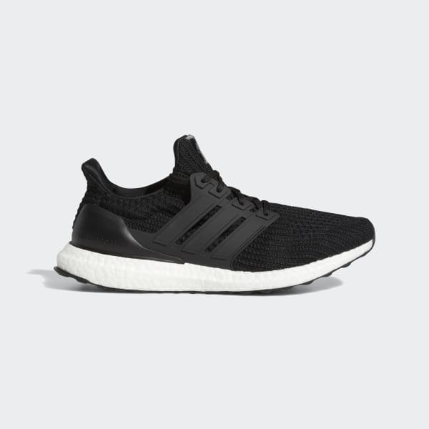Adidas Ultraboost 4.0 DNA – Core Black/Cloud White

MYR759.00

Size – UK3.5 / UK4 / UK4.5 / UK5 / UK5.5 / UK6 / UK6.5 / UK7 / UK7.5 / UK8 / UK8.5 / UK9 / UK9.5 / UK10 / UK10.5 / UK11 / UK11.5 / UK12 / UK12.5 / UK13.5

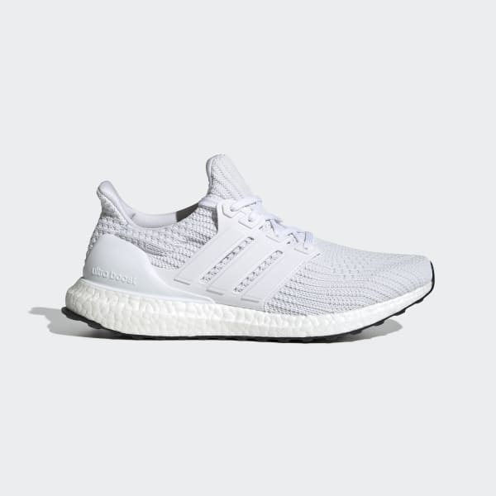Adidas Ultraboost 4.0 DNA – Cloud White/Core Black

MYR759.00

Size – UK3.5 / UK4 / UK4.5 / UK5 / UK5.5 / UK6 / UK6.5 / UK7 / UK7.5 / UK8 / UK8.5 / UK9 / UK9.5 / UK10 / UK10.5 / UK11 / UK11.5 / UK12 / UK12.5 / UK13.5

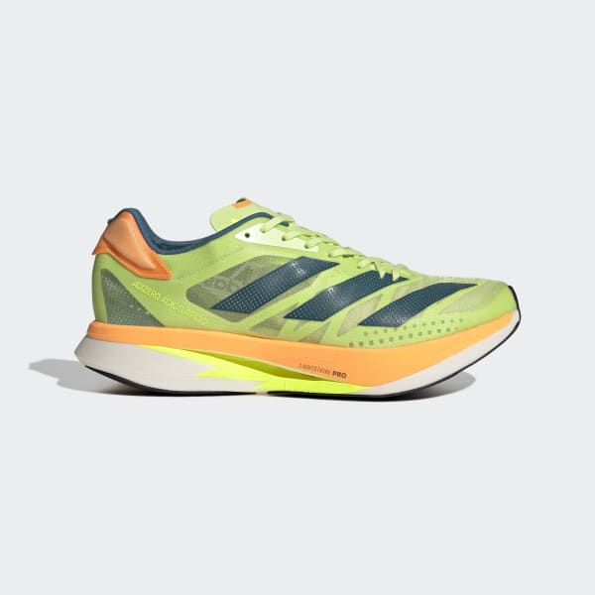Adizero Adios Pro 2.0 – Pulse Lime/Real Teal/Flash Orange

MYR899.00

Size – UK10.5 / UK11 / UK12

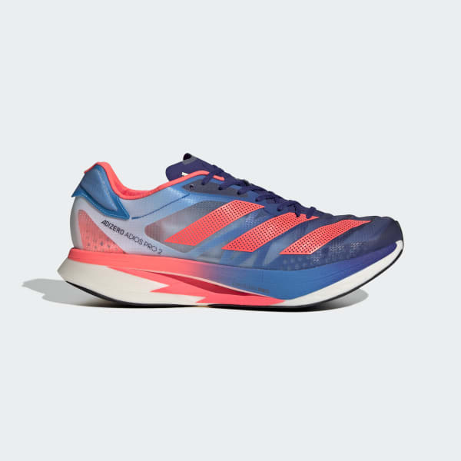Adizero Adios Pro 2.0 – Legacy Indigo/Turbo/Sky Rush

MYR899.00

Size – UK11 / UK12

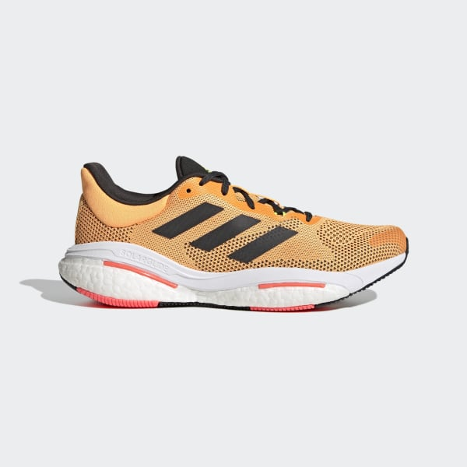Adidas Solarglide 5 – Flash Orange/Carbon/Turbo

MYR599.00

Size – UK6 / UK6.5 / UK7 / UK7.5 / UK8 / UK8.5 / UK9 / UK9.5 / UK10 / UK10.5 / UK11 / UK11.5 / UK12 / UK12.5 / UK13.5

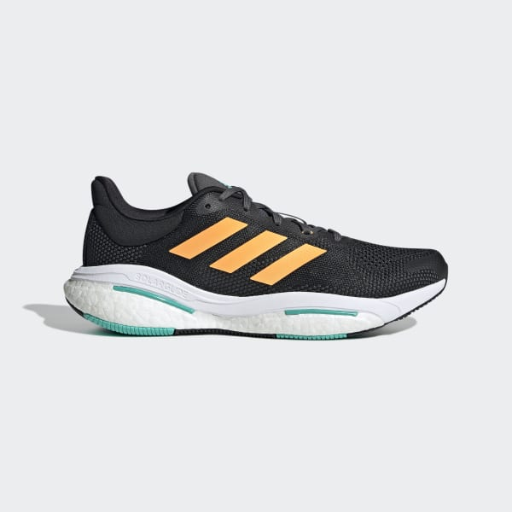Adidas Solarglide 5 – Core Black/Flash Orange/Mint Rush

MYR599.00

Size – UK7 / UK7.5 / UK8 / UK8.5 / UK9 / UK9.5 / UK10

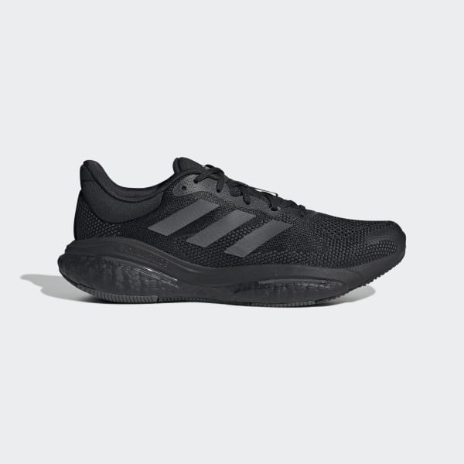

Adidas Solarglide 5 – Core Black/Grey Six/Carbon

MYR599.00

Size – UK6 / UK6.5 / UK7 / UK7.5 / UK8 / UK8.5 / UK9 / UK9.5 / UK10 / UK10.5 / UK11 / UK11.5 / UK12 / UK12.5 / UK13.5

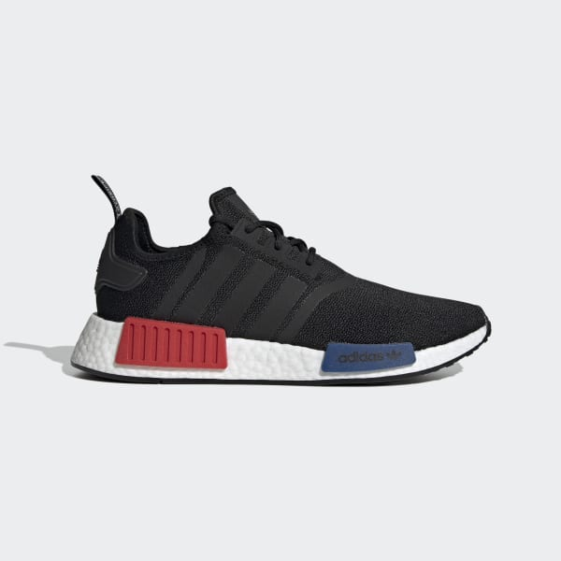Adidas NMD_R1 – Core Black/Cloud White

MYR669.00

Size – UK4 / UK4.5 / UK5 / UK5.5 / UK6 / UK6.5 / UK7 / UK7.5 / UK8 / UK8.5 / UK9 / UK9.5 / UK10 / UK12.5

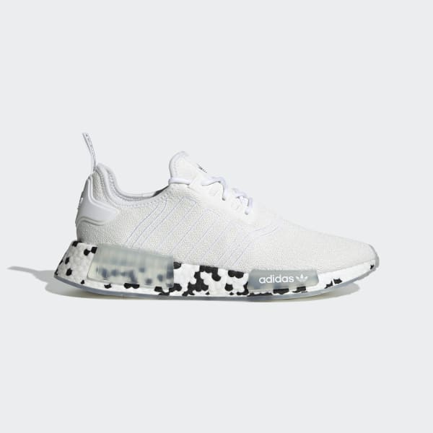Adidas NMD_R1 – Cloud White/Sonic Aqua

MYR669.00

Size – UK4.5 / UK7 / UK8 / UK9

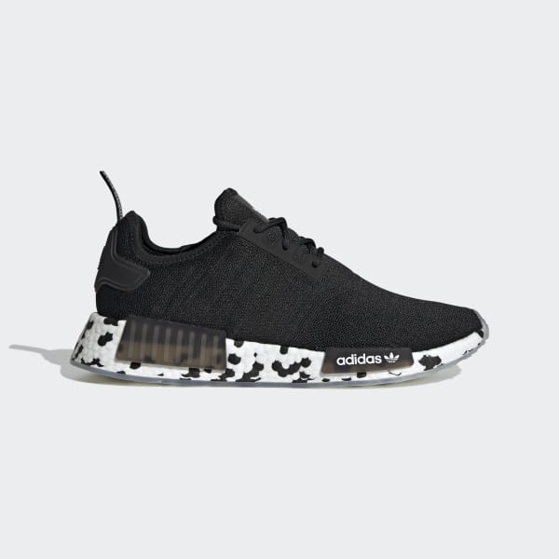Adidas NMD_R1 – Core Black/Cloud White

MYR669.00

Size – UK7

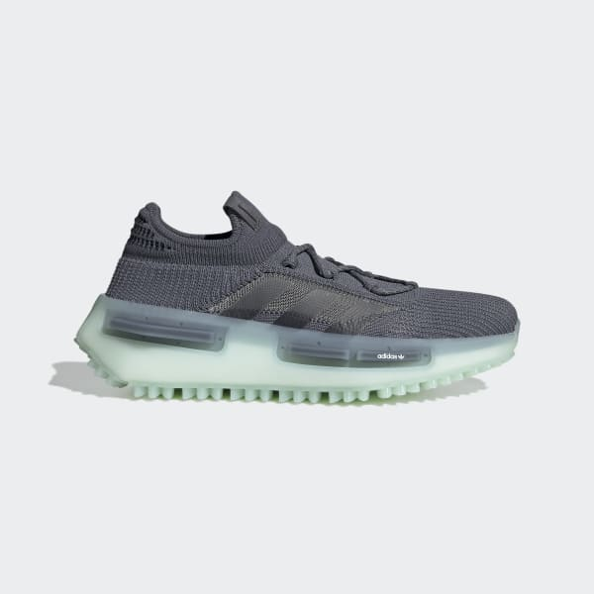Adidas NMD_S1 – Ice Mint/Onyx

MYR799.00

Size – UK4.5 / UK6 / UK6.5 / UK7

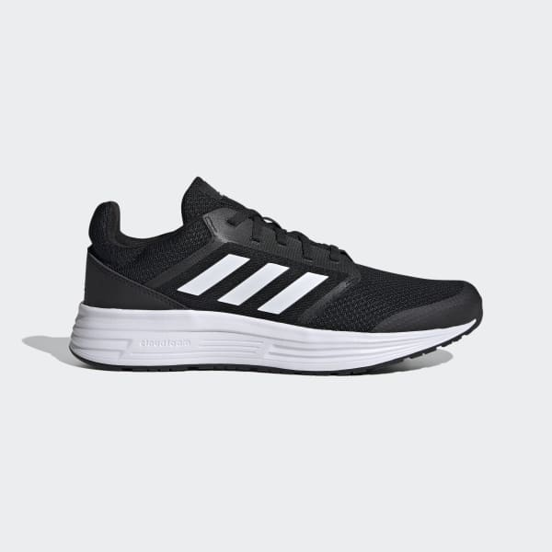Adidas Galaxy 5 – Core Black/Cloud White

MYR249.00

Size – UK6 / UK6.5 / UK7.5 / UK8 / UK8.5 / UK10 / UK10.5 / UK11 / UK11.5 / UK12

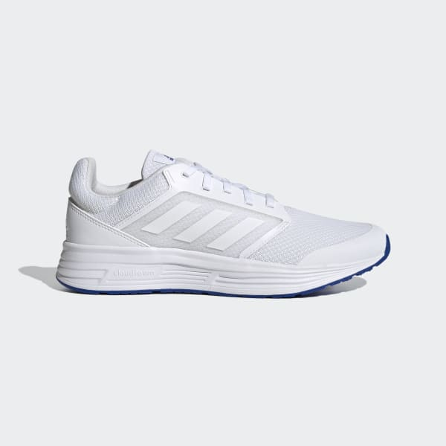 Adidas Galaxy 5 – Cloud White/Royal Blue

MYR249.00

Size – UK7 / UK7.5 / UK8 / UK8.5 / UK9 / UK9.5 / UK10 / UK10.5 / UK11 / UK11.5

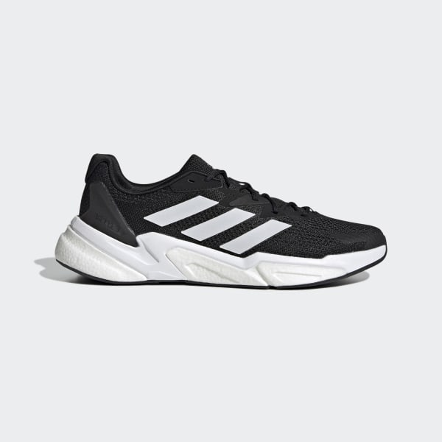

Adidas X9000L3 – Core Black/Cloud White

MYR499.00

Size – UK6 / UK6.5 / UK7 / UK7.5 / UK8 / UK8.5 / UK9 / UK9.5 / UK10 / UK10.5 / UK11 / UK11.5 / UK12 / UK12.5 / UK13.5

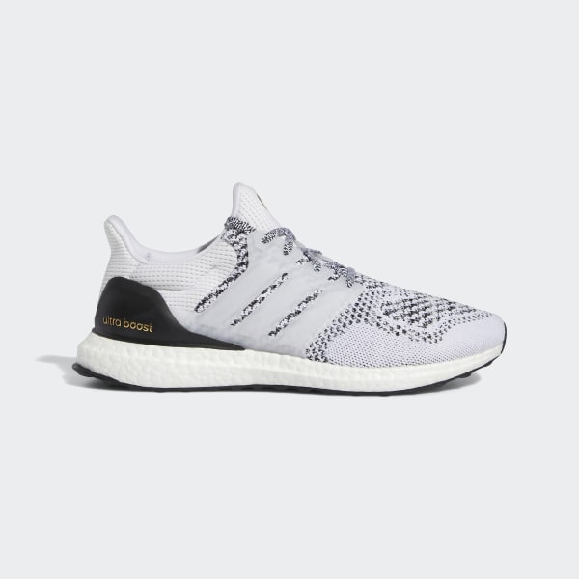Adidas Ultraboost 1.0 DNA – Cloud White/Core Black

MYR799.00

Size - UK3.5 / UK4 / UK4.5 / UK5 / UK5.5 / UK6 / UK6.5 / UK7 / UK7.5 / UK8 / UK8.5 / UK9 / UK9.5 / UK10 / UK10.5 / UK11 / UK11.5 / UK12